# Java 9 改进 Javadoc

javadoc 工具可以生成 Java 文档， Java 9 的 javadoc 的输出现在符合兼容 HTML5 标准。

**Java 9 之前的旧版本文档**

考虑以下文件代码 C:/JAVA/Tester.java:

## 实例

/** * @author MahKumar * @version 0.1 */ public class Tester { /** * Default method to be run to print * <p>Hello world</p> * @param args command line arguments */ public static void main(String []args) { System.out.println("Hello World"); } }

使用 jdk 7 的 javadoc 生成文档：

C:\JAVA>javadoc -d C:/JAVA Tester.javaLoading source file tester.java...Constructing Javadoc information...Standard Doclet version 1.7.0_21Building tree for all the packages and classes...Generating C:\JAVA\Tester.html...Generating C:\JAVA\package-frame.html...Generating C:\JAVA\package-summary.html...Generating C:\JAVA\package-tree.html...Generating C:\JAVA\constant-values.html...Building index for all the packages and classes...Generating C:\JAVA\overview-tree.html...Generating C:\JAVA\index-all.html...Generating C:\JAVA\deprecated-list.html...Building index for all classes...Generating C:\JAVA\allclasses-frame.html...Generating C:\JAVA\allclasses-noframe.html...Generating C:\JAVA\index.html...Generating C:\JAVA\help-doc.html...

执行以上命令会再 C:/JAVA 命令下生成文档页面，如下图所示：

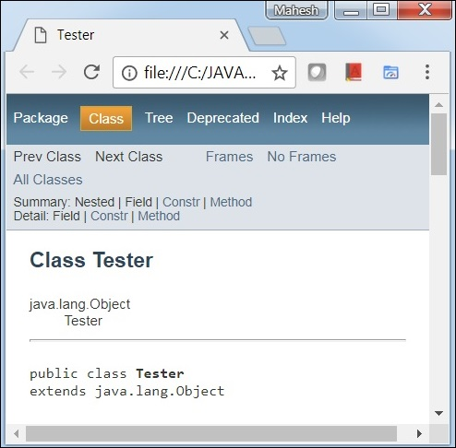

**Java 9 生成的文档兼容 HTML5 标准**

使用 jdk 9 javadoc 命令中的 **-html5** 参数可以让生成的文档支持 HTML5 标准：

C:\JAVA> javadoc -d C:/JAVA -html5 Tester.javaLoading source file Tester.java...Constructing Javadoc information...Standard Doclet version 9.0.1Building tree for all the packages and classes...Generating C:\JAVA\Tester.html...Generating C:\JAVA\package-frame.html...Generating C:\JAVA\package-summary.html...Generating C:\JAVA\package-tree.html...Generating C:\JAVA\constant-values.html...Building index for all the packages and classes...Generating C:\JAVA\overview-tree.html...Generating C:\JAVA\index-all.html...Generating C:\JAVA\deprecated-list.html...Building index for all classes...Generating C:\JAVA\allclasses-frame.html...Generating C:\JAVA\allclasses-frame.html...Generating C:\JAVA\allclasses-noframe.html...Generating C:\JAVA\allclasses-noframe.html...Generating C:\JAVA\index.html...Generating C:\JAVA\help-doc.html...

执行以上命令会再 C:/JAVA 命令下生成文档页面，如下图所示：

